Table of Contents

Executive Summary 3

ES-05 Executive Summary - 91.200(c), 91.220(b) 3

The Process 8

PR-05 Lead & Responsible Agencies - 91.200(b) 8

PR-10 Consultation - 91.100, 91.200(b), 91.215(l) 9

PR-15 Citizen Participation - 91.401, 91.105, 91.200(c) 12

Needs Assessment 13

NA-05 Overview 13

NA-50 Non-Housing Community Development Needs - 91.415, 91.215 (f) 18

Housing Market Analysis 20

MA-05 Overview 20

MA-45 Non-Housing Community Development Assets - 91.410, 91.210(f) 24

MA-50 Needs and Market Analysis Discussion 31

Strategic Plan 39

SP-05 Overview 39

SP-10 Geographic Priorities - 91.415, 91.215(a)(1) 41

SP-25 Priority Needs - 91.415, 91.215(a)(2) 42

SP-65 Lead-based Paint Hazards - 91.415, 91.215(i) 53

SP-70 Anti-Poverty Strategy - 91.415, 91.215(j) 54

SP-80 Monitoring - 91.230 55

Expected Resources 57

AP-15 Expected Resources - 91.420(b), 91.220(c)(1,2) 57

Annual Goals and Objectives 60

AP-38 Project Summary 63

AP-50 Geographic Distribution - 91.420, 91.220(f) 66

AP-85 Other Actions - 91.420, 91.220(k) 68

Program Specific Requirements 70

# Executive Summary

## ES-05 Executive Summary - 91.200(c), 91.220(b)

1. **Introduction**

Bensalem Township is a federal entitlement community under the U.S. Department of Housing and Urban Development’s Community Development Block Grant (CDBG) Program and the HOME Investment Partnerships Program (HOME). As a HUD entitlement community, the City is required to prepare a Five-Year Consolidated Plan (CP) in order to implement any federal programs that fund housing, community development and economic development within the community. The Bensalem Township CP covers the period from FY 2015 through FY 2019 (April 1, 2015 through March 31, 2019). This CP will be submitted to HUD for approval.

The lead entity responsible for the preparation of the CP is the Bensalem Township Community Development office.

Bensalem Township has, through the CP, developed a single, consolidated planning and application document in consultation with public and private agencies. The CP for Bensalem Township will serve the following functions:

* A planning document that enables the Township to view its HUD funding, not in isolation, but as one tool in a comprehensive strategy to address housing, community development, and economic development needs
* An application for CDBG Program funds under HUD's formula grant
* A strategy document to be followed in carrying out HUD programs, and
* An action plan that provides a basis for assessing performance in the investment of CDBG funds.

***Purpose of the Consolidated Plan***

The purpose of the Consolidated Plan (CP) is to guide federal funding decisions in the next five years. The CP is guided by three overarching goals that are applied according to a community’s needs. The goals are:

* To provide decent housing by preserving the affordable housing stock, increasing the availability of affordable housing, reducing discriminatory barriers, increasing the supply of supportive housing for those with special needs, and transitioning homeless persons and families into housing.
* To provide a suitable living environment through safer, more livable neighborhoods, greater integration of low- and moderate- income residents throughout the Township, increased housing opportunities, and reinvestment in deteriorating communities.
* To expand economic opportunities through more jobs paying self-sufficient wages, homeownership opportunities, development activities that promote long-term community viability, and the empowerment of low- and moderate- income persons to achieve self-sufficiency.

The overall priority for the investment of federal funds is to increase self-sufficiency and economic opportunity for lower income residents and individuals with special needs so that they can achieve a reasonable standard of living.

Bensalem Township will receive the following estimated federal resources in FY 2015; estimated projections for five years follow in parentheses:

* CDBG: $253,042 ($1,265,210)

1. **Summary of the objectives and outcomes identified in the Plan**

The Strategic Plan provides a framework to address the needs of the Township for the next five years using Community Development Block Grant (CDBG) funds. The three overarching objectives guiding the proposed activities are:

* Providing Decent Affordable Housing
* Creating Suitable Living Environments
* Creating Economic Opportunities

Outcomes show how programs and activities benefit a community or the people served. The three outcomes that will illustrate the benefits of each activity funded by the CDBG program are:

* Improve Availability/Accessibility
* Improve Affordability
* Improve Sustainability

All future activities funded in the next five years will support at least one objective and one outcome.

The Township created the following Statement of Objectives:

1. The conservation and expansion of the Township housing stock for all persons, but principally those of low- and moderate- income
2. The expansion and improvement of the quality and quantity of community services and facilities, principally for persons of low- and moderate- income
3. The promotion of economic development and the creation of new jobs and the retention of existing jobs
4. The elimination of slum and blight and the prevention of blighting influences
5. The elimination of conditions which are detrimental to health, safety and public welfare
6. The preparation of plans for a better utilization of land and other natural resources
7. The restoration and preservation of properties of historic value.
8. **Evaluation of past performance**

Bensalem Township prepared a Consolidated Annual Performance and Evaluation Report (CAPER) for FY 2013 (April 1, 2013 to March 31, 2014). This CAPER was the fourth of the prior five-year period and reported the FY 2013 accomplishments of the Township’s CDBG Program. The following is a summary of the accomplishments detailed in the FY 2013 CAPER:

* Housing rehabilitation assistance in conjunction with the assistance of the county redevelopment authority was provided to 4 households.
* The Township continued to fund the homeless shelter now operated by the Family Service Association.
* The Township continued to work with local municipalities on promoting an Enterprise Zone and was an active participant on the task force.
* The Township worked with the Bucks County Redevelopment Authority and the Industrial Development Corporation to promote economic development activities.
* The Township continued to participate in the expansion of the Transportation Management Association (TMA). TMA is working to increase public transportation in the area.
* The Township continued to work with area agencies and groups on issues related to the Delaware River, including land reclamation and clean-up.
* The Township updated its Fair Housing Analysis to meet the requirements of 24 CFR 470.904 (c). The Township adopted Ordinance 2013-03 to delete the required minimum dwelling unit sizes. The Township also added interpretive language to Section 232-4 of the General Provisions of the Zoning Ordinance.

In FY 2013, all CDBG funds expended for activities met one of the national objectives as defined under the CDBG regulations. In FY 2013, CDBG-funded activity expenditures totaled $249,000, with 100% benefiting low- and moderate-income persons.

1. **Summary of citizen participation process and consultation process**

Bensalem Township’s goal for citizen participation is to ensure a broad participation of Township residents, local jurisdictions, housing, economic, and service providers in the planning and implementation of community development and housing programming. Citizen participation takes the form of advertised community meetings and public hearings.

The planning process for the preparation of the Five-Year Consolidated Plan and FY 2015 Annual Action Plan included the following distinct elements:

* Focus group sessions with representatives from City government (staff) and interviews with non-profit organizations and other service providers to gain stakeholder input on the identification of Township needs.
* Additional meetings and telephone interviews with Township departmental staff and other provider agencies and stakeholders throughout the planning process to understand the current scope of programs, issues, and concerns. The one-on-one conversations helped to develop strategies to address the community needs that were identified in the focus group sessions.
* Review of existing community development-related planning documents, including the Bensalem Township Comprehensive Plan (2002) and a recent long-term riverfront development plan (2013-2014).

Two public hearings were held during the consolidated planning process. The first meeting was held on December 19, 2014 and the second meeting was held on January 14, 2015. These meetings were advertised in the Bucks County Courier Times.

1. **Summary of public comments**

No public comments were received at either the December 19, 2014 meeting or the January 14, 2015 meeting.

1. **Summary of comments or views not accepted and the reasons for not accepting them**

No public comments were received at either the December 19, 2014 meeting or the January 14, 2015 meeting.

1. **Summary**

See above.

# The Process

## PR-05 Lead & Responsible Agencies - 91.200(b)

**1. Describe agency/entity responsible for preparing the Consolidated Plan and those responsible for administration of each grant program and funding source**

The following are the agencies/entities responsible for preparing the Consolidated Plan and those responsible for administration of each grant program and funding source.

| **Agency Role** | **Name** | **Department/Agency** |
| --- | --- | --- |
| Lead Agency | BENSALEM TOWNSHIP | Community Development Office |

Table 1– Responsible Agencies

**Narrative**

Bensalem Township’s Community Development office is the lead agency responsible for the preparation of the Five-Year Strategic Plan and administration of the CDBG program.

Recommendations are made to the mayor and City Council in August, with submittal of a final program budget to HUD by mid-November. CYDCD’s Bureau of Housing Services administers the CDBG and HOME programs on behalf of the City.

**Consolidated Plan Public Contact Information**

**Bensalem Township**

Municipal Building

Community Development Office

2400 Byberry Road

Bensalem Township, PA 19020

Contact: William Cmorey, Director of Administration

Phone: 215.633.3602

Email: wcmorey@bensalempa.gov

Website: www.bensalempa.gov

## PR-10 Consultation - 91.100, 91.200(b), 91.215(l)

1. **Introduction**

Bensalem Township places emphasis on coordinated action within and between Township departments, local and regional public agencies, and local nonprofit organizations. Coordinated actions include programmatic linkages between departments as well as budget allocation process coordination.

**Provide a concise summary of the jurisdiction’s activities to enhance coordination between public and assisted housing providers and private and governmental health, mental health and service agencies (91.215(I)).**

Bensalem Township’s Community Development office staff coordinates actively with other departments, Bucks County, and other agencies. Collaboration and coordination with these entities will continue in order to capitalize on existing investments. The Township, through its Office of Community Development, maintains contact with County housing agencies. The Community Development Office works closely with the County Redevelopment Authority, Bucks County Housing Authority and the Bucks County Housing Development Corporation to provide decent and safe housing. The Township is also working with various local municipalities, the Redevelopment Authority, and the Bucks County Industrial Development Corporation in its effort to promote economic development through the Enterprise Zone program.

**Describe coordination with the Continuum of Care and efforts to address the needs of homeless persons (particularly chronically homeless individuals and families, families with children, veterans, and unaccompanied youth) and persons at risk of homelessness**

As part of the Housing Continuum of Care-Bucks County (HCoC-BC), the Township cooperates with the County’s Office of Community Development and its Continuum of Care plan to assist local homeless populations. The Township cooperates with the County in providing support on a local level for those programs, which provide transitional housing and support for new low-cost permanent housing. Additionally, the Township works with the Bucks County Redevelopment Authority on various housing initiatives, including compliance with lead-based paint hazard regulations. The City will continue to support the HCoC-BC strategy to meet the needs of homeless persons and those at risk of becoming homeless.

**Describe consultation with the Continuum(s) of Care that serves the jurisdiction's area in determining how to allocate ESG funds, develop performance standards and evaluate outcomes, and develop funding, policies and procedures for the administration of HMIS**

The Township does not receive ESG funds.

1. **Describe Agencies, groups, organizations and others who participated in the process and describe the jurisdictions consultations with housing, social service agencies and other entities**

A wide variety of stakeholders were consulted to determine the Township’s housing and community development needs. The parties consulted included housing and social service agencies and private nonprofit organizations whose missions include the provision of affordable housing and human services to low- and moderate- income residents.

**Identify any Agency Types not consulted and provide rationale for not consulting**

The Township consulted with a wide-range of stakeholders, either through focus group meetings, personal interviews and/or questionnaires.

**Other local/regional/state/federal planning efforts considered when preparing the Plan**

| **Name of Plan** | **Lead Organization** | **How do the goals of your Strategic Plan overlap with the goals of each plan?** |
| --- | --- | --- |
| Bensalem Township Comprehensive Plan 2002 | Bensalem Township | The Comprehensive Plan was reviewed to match the CP/AP goals. |
| Bucks County Analysis of Impediments to Fair Housing Choice (2014) | Bucks County | The Fair Housing Action Plan implementation recommendations from the AI were reviewed for the CP. |
| Housing Continuum of Care-Bucks County (HCoC-BC) Community Impact Report | Housing Continuum of Care-Bucks County (HCoC-BC) | The goals in the 10 Year Plan provided a framework for the homeless needs section. |
| Bensalem 2018 Riverfront Redevelopment Plan and Regulating Code (PowerPoint presentation) | Bensalem Township | The Riverfront Plan summary was useful for the economic development section of the CP. |

Table 3– Other local / regional / federal planning efforts

**Describe cooperation and coordination with other public entities, including the State and any adjacent units of general local government, in the implementation of the Consolidated Plan (91.215(l))**

In accordance with 24 CFR 91.100(4), Bensalem Township will notify adjacent units of local government of the non-housing community development needs included in its CP. The Township will continue to interact with public entities at all levels to ensure coordination and cooperation in the implementation of the Consolidated Plan and thereby maximize the benefits of the Township’s housing and community development activities for the residents being served. In addition, a copy of the completed CP will be sent to the Bucks County Commissioner’s Office and to the State Department of Community and Economic Development (DCED).

## PR-15 Citizen Participation - 91.401, 91.105, 91.200(c)

**1. Summary of citizen participation process/Efforts made to broaden citizen participation**

**Summarize citizen participation process and how it impacted goal-setting**

In agreement with 24 CFR 91.115(e), Bensalem Township has adopted a Citizen Participation Plan describing the citizen participation requirements of its CDBG program. The Citizen Participation Plan is on file at the Community Development office.

A public needs hearing was held on December 19, 2014. A second public hearing was held on January 14, 2015. Both hearings were held in the Municipal Building. The public hearings were advertised in the Bucks County Courier Times. Notification of both hearings was also posted at the Township Clerk’s Office in Township Hall, and on-line via the Township’s website: http://bensalempa.gov.

Copies of the FY 2015-2019 Consolidated Plan and the FY 2015 Action Plan were placed on display in public locations for public review and comment. A copy of the CP was placed on the Township’s web site and was available at the municipal building and the Bucks County Housing Authority.

**Citizen Participation Outreach**

| **Sort Order** | **Mode of Outreach** | **Target of Outreach** | **Summary of**  **response/**  **attendance** | **Summary of**  **comments**  **received** | **Summary of**  **comments not accepted and reasons** | **URL (If applicable)** |
| --- | --- | --- | --- | --- | --- | --- |
| 1 | Public hearing: December 19, 2014 | Township-wide | 0 people attended | No comments were received | No comments were received | N/A |
| 2 | Final Public Hearing: January 14, 2015 | Township-wide | 0 people attended | No comments were received | No comments were received | N/A |

Table 4– Citizen Participation Outreach

# Needs Assessment

## NA-05 Overview

**Needs Assessment Overview**

Bensalem Township is a member of the Bucks County HOME Consortium, and as such the full Needs Assessment section is in the Bucks County HOME Consortium Consolidated Plan. No separate Needs Assessment is available specifically for Bensalem Township. To provide an overview on housing problems, housing cost burden, and severe housing cost burden for the Township, the HUD CPD Maps tool was utilized. The maps on the following pages provide a visual overview of the three housing issues.

Severe Housing Problems: Low-Income Households

HUD defines a disproportionately greater housing need when a household experiences housing problems at a rate greater than for the income level as a whole. The distinction between housing problems and severe housing problems is the degree of cost burden and overcrowding. The data is based on low-income households (30%-50% median household income) experiencing severe housing problems by HUD Adjusted Median Family Income (AMI) levels. The map below was created in CPD Maps (ESRI) based on 2007-2011 CHAS data. Housing problems include:

* Housing units lacking complete kitchen facilities and/or complete plumbing facilities
* Overcrowding (more than 1.5 persons per room)
* Cost burden greater than 50%

According to data from the map, Census Tracts 1002.11, 1002.06, 1002.07, 1002.08, part of 1001.05, and 1001.02 contain the largest number of low-income households with severe housing problems in Bensalem Township, ranging from 60.47% to 83.64% of the low-income households. Three of census tracts, 1001.02, 1002.07, and 1002.08, contain designated LMI block groups.

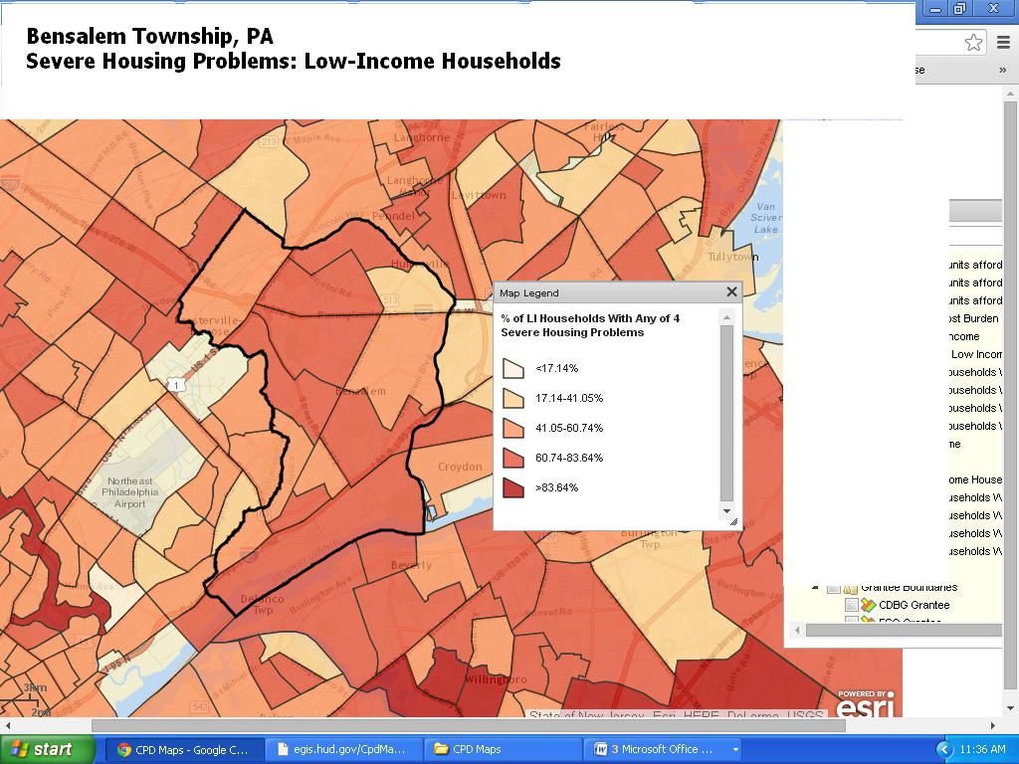

Severe Housing Problems: Extremely Low-Income Households

Similar to the definition above, extremely low-income households consist of those with incomes between 0-30% of median household income. According to data from the map, Census Tracts 1001.02, 1002.06, 1002.08, and 1002.10, contain the largest number of households with severe housing cost burden for extremely low-income households in Bensalem Township, with 87.76% and over of extremely low-households paying more than 50% of their income on housing costs, resulting in severe housing problems.

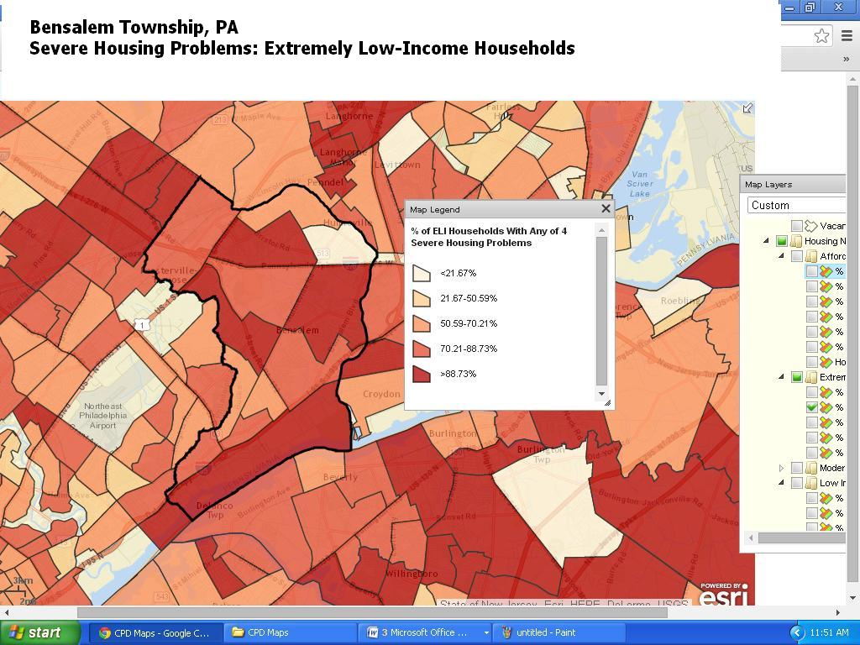

Housing Cost Burden

HUD defines a disproportionately greater housing need as when a household experiences housing problems at a rate greater than for the income level as a whole. The map below was created in CPD Maps (ESRI) based on 2007-2011 CHAS data. The data is based on households experiencing housing problems by HUD Adjusted Median Family Income (AMI) levels. Housing problems include:

* Housing units lacking complete kitchen facilities and/or complete plumbing facilities
* Overcrowding (more than one person per room)
* Cost burden greater than 30%

According to data from the map, Census Tracts 1002.07 and 1001.02 contain the largest number of households with housing cost burden in Bensalem Township, ranging from 44.93% to 72.96% of the households paying more than 30% of their income on housing costs, resulting in a housing cost burden. These two census tracts also contain designated LMI block groups.

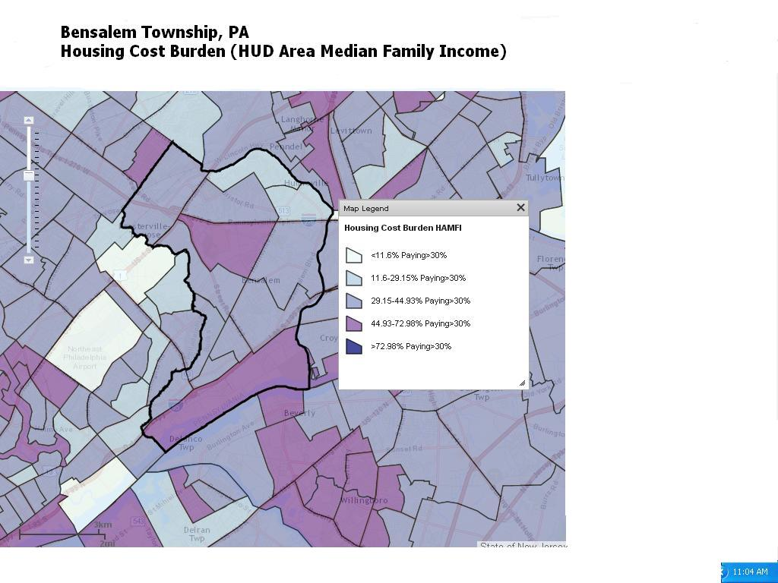

Severe Housing Cost Burden: Extremely Low-Income Households

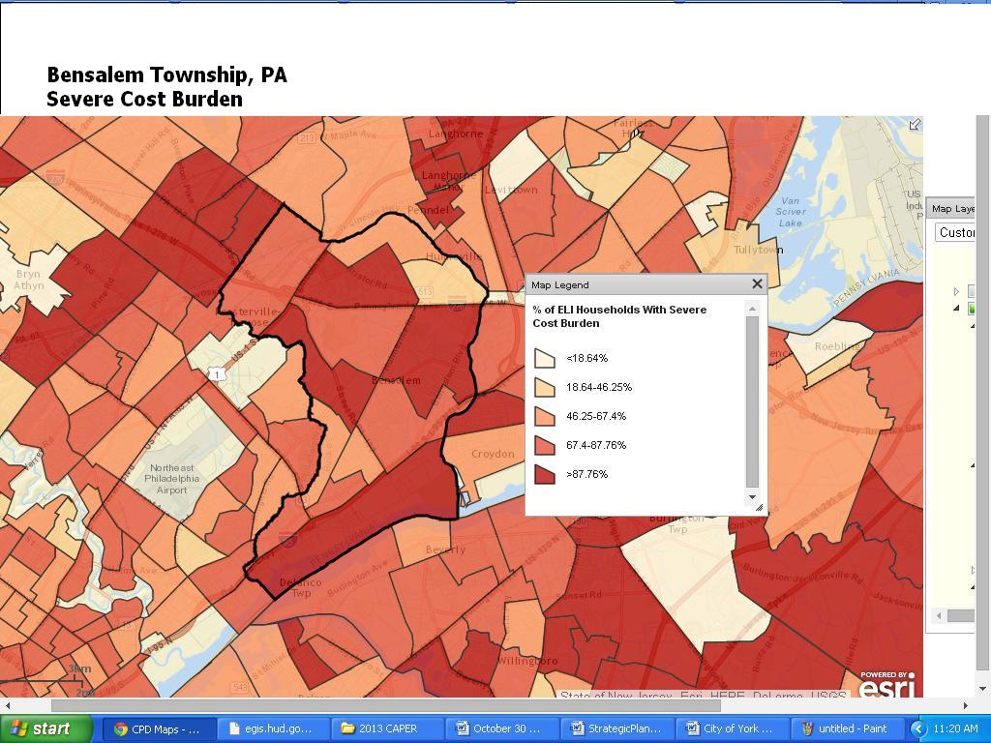Similar to the definition above, severe housing cost burden is the point when extremely low-income households spend more than 50% of their gross income on housing costs. According to data from the map, Census Tracts 1001.02, 1002.06, 1002.08, and 1002.10, contain the largest number of households with severe housing cost burden for extremely low-income households in Bensalem Township, with 87.76% of extremely low-households paying more than 50% of their income on housing costs in these four areas, resulting in severe housing cost burden.

## NA-50 Non-Housing Community Development Needs - 91.415, 91.215 (f)

**Describe the jurisdiction’s need for Public Facilities:**

Public facility improvements in Bensalem Township are important to supporting the quality of life by providing adequate space for the provision of services, holding of events that bring the community together, and addressing public safety concerns. In addition, Bensalem’s various public facilities also support the need for open space and recreation amidst the Township’s suburban setting. The Township will continue to support its various community development needs through public facilities improvements. The Township recognizes the need to improve its infrastructure and has taken a pro-active approach to addressing those needs. CDBG funds will not be used to address the public facility needs due to the limited federal allocation. General Township tax revenues will be used to address public facility needs.

**Short-Term Goals:** Bensalem Township will maintain and improve, where feasible, the quality of local public facilities to ensure their continued availability to all residents.

**Long-Term Goals:** Bensalem Township will support improvement projects that include rehabilitation, repairs, accessibility improvements, and other enhancements to public facilities, such as parks and playgrounds safety replacements, police and fire stations, parking facilities, parks, and municipal facilities.

**How were these needs determined?**

Public facility needs were determined through discussions with Township government departments and staff.

**Describe the jurisdiction’s need for Public Improvements:**

As an older community, the infrastructure in Bensalem Township is in need of constant upgrades and improvements. Maintaining and improving the Township’s infrastructure is important in the support of the long-term viability of Bensalem Township as a place to live, work, play, and operate a business.

Public improvements are needed in many CDBG-eligible areas of Bensalem Township. Priority projects in the infrastructure category include the reconstruction of streets and sidewalks that are heavily traveled and in need of repair (including curb cut improvements, repaving, streetscape beautification, and tree planting). In addition, water and sewer improvements and storm water management improvements are a high priority in the Township. Infrastructure improvement projects will contribute to the safety and quality of life of neighborhoods throughout Bensalem Township and will benefit LMI persons.

**Short-Term Goals:** In FY 2015, the Township will support curb cut improvements to remove architectural barriers for disabled persons.

**Long-Term Goals:** Bensalem Township will provide financial assistance to improve the existing infrastructure in the Township, including street reconstruction, sidewalk improvements, streetscape enhancements, storm water management, sanitary sewer service, and reduced flooding. Most of these improvements will be funded with the use of Township tax revenues and other county, state, or federal resources that may be available to fund large-scale public improvement projects.

**How were these needs determined?**

Public improvement needs were determined through discussions with Township government departments and staff.

**Describe the jurisdiction’s need for Public Services:**

There are a variety of public services available in Bensalem Township to address human service needs. In addition, there continues to be service needs that are important to the long-term ability of persons in Bensalem to live independently and to improve their economic status. Bensalem Township will continue to support innovative services that address outstanding needs that provide a benefit to wide sectors of the community.

**Short-Term Goals:** The Township will support crime awareness and prevention activities through the Township’s Police Department’s community policing program.

**Long-Term Goals:** Bensalem will support vital public services such as youth programs, education and self-sufficiency programs, homeownership counseling programs, neighborhood policing, and other services to address the needs of LMI households in the Township.

**How were these needs determined?**

Public service needs were determined through discussions with Township government departments and staff, in addition to discussions with the CoC.

# Housing Market Analysis

## MA-05 Overview

**Housing Market Analysis Overview:**

The housing stock in Bensalem Township consists primarily of single-family owner-occupied units with three or more bedrooms.

The rate of growth in Bensalem’s housing stock has been faster than that of Bucks County and of Pennsylvania as a whole. In Bensalem Township between 1990 and 2012 the number of housing units grew 11.5%, or 3,529 units, from 23,535 to 26,240 total housing units. In contrast, Bucks County’s housing stock grew by 8.9% and Pennsylvania’s by 6%.

Between 2000 and 2012, the number of owner-occupied units increased 9.9%, from 13,143 to 14,443, while the number of renter-occupied units fell, from 9,484 to 8,789, a decline of 7.3%. Vacant units have also increased. In 2000 vacant units represented 3.9% of Bensalem’s total housing stock, with 908 units. By 2012, the number of vacant properties had nearly tripled, to 3,008, comprising 11.5% of total stock.

The majority (59.4%) of the units in Bensalem Township are single-family, a lower rate than Bucks County (78.6%) and Pennsylvania (73%).

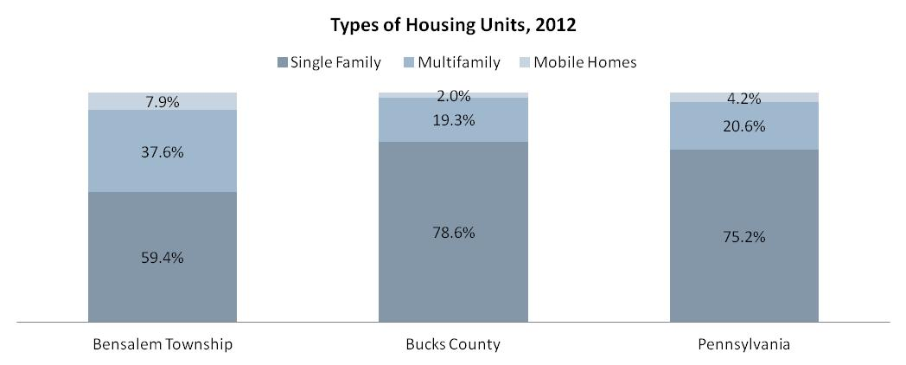

The following chart shows that renter-occupied units in Bensalem Township decreased from 2000-2012, while the percentage of renter-occupied units in Bucks County also decreased but at a much slower rate. Pennsylvania experienced a slight increase during the same time period.

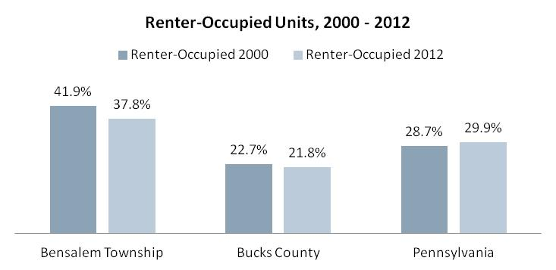

**Cost of Housing:**

The median home value in Bensalem Township increased rapidly between 2000 and 2012, increasing by 52.1%, even with the decline in the housing market from 2008-2010. The 2012 median home value was $266,700, a price unaffordable to low- and moderate-income households. The median gross rent rose a less rapid 7%.

Another gauge of housing cost in the Township is the number of cost burdened households. Cost-burdened households are households that pay 30% or more of their income on housing costs. The percent of cost-burdened owner-households has declined slightly, from 39.5% in 2011 to 38.6% in 2012, a rate higher than the rates for Bucks County and the state.

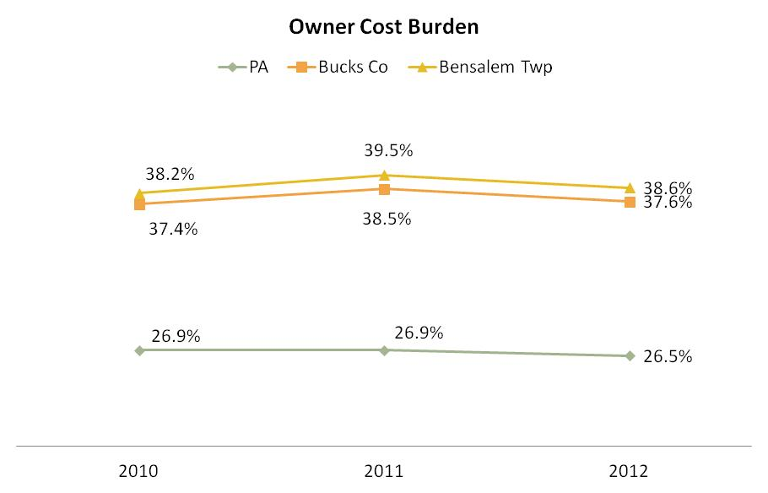

Data from the 2012 ACS also reveals an increasing cost burden for renter-occupied households in the Township. For Township renter-households, the rate of cost burden in 2012 (51.8%) was lower than it was in 2010 (51.3%) and remains close to the rate for Bucks County, but well above the rate for the state.

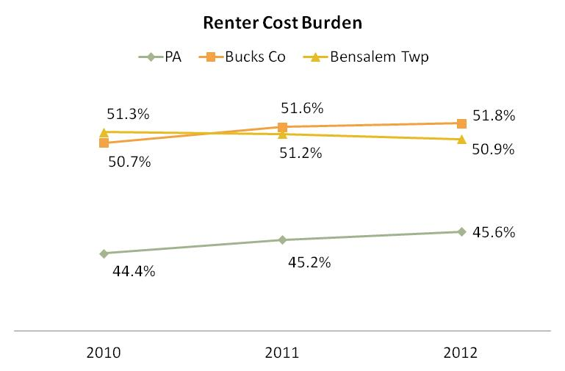

**Year Unit Built**

Over 41% of the housing stock in Bensalem Township was built between 1970 and 1979, and while the housing in Bucks County overall tends to be older, with more units built before 1939, the County also has more housing built since 1980, 37% in Bucks County compared to 25% in Bensalem Township.

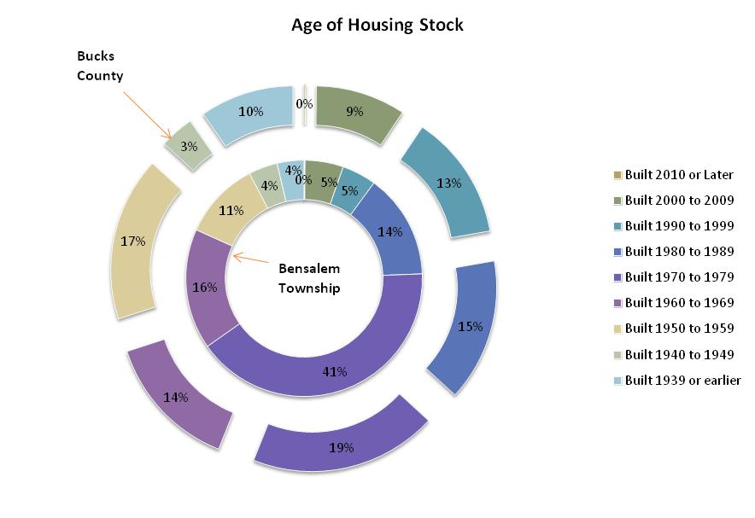

## MA-45 Non-Housing Community Development Assets - 91.410, 91.210(f)

**Introduction**

The Education and Health Care Services sector has largest number of workers who live in the Township, according to the Business Activity table below. This sector alone represents almost one-fifth of the employment for Township residents.

According to the data by occupation, the Management, Business, and Financial sector is the largest, with 28% of Township residents working in this sector. This is consistent with the types of employment opportunities available for Township residents. Education and Health Care Services continue to be the main drivers of the area’s economy.

The economy of Bensalem Township reflects the larger economy of the Philadelphia region, Bucks County, and Pennsylvania. According to the Bucks County Workforce Investment Board (WIB), a high percentage of Bensalem Township residents work outside of the Township, including in employment centers in Philadelphia and New Jersey.

**Economic Development Market Analysis**

The following HUD-generated tables contain data pertinent to economic development in Bensalem Township. Discussion and analysis of the data follows the Educational Attainment table**.**

**Business Activity**

| **Business by Sector** | **Number of Workers** | **Number of Jobs** | **Share of Workers**  **%** | **Share of Jobs**  **%** | **Jobs less workers**  **%** |
| --- | --- | --- | --- | --- | --- |
| Agriculture, Mining, Oil & Gas Extraction | 45 | 3 | 0 | 0 | 0 |
| Arts, Entertainment, Accommodations | 2,592 | 4,881 | 10 | 13 | 2 |
| Construction | 1,180 | 2,320 | 5 | 6 | 1 |
| Education and Health Care Services | 4,927 | 3,970 | 20 | 10 | -9 |
| Finance, Insurance, and Real Estate | 1,929 | 2,271 | 8 | 6 | -2 |
| Information | 671 | 1,572 | 3 | 4 | 1 |
| Manufacturing | 2,757 | 3,561 | 11 | 9 | -2 |
| Other Services | 926 | 947 | 4 | 2 | -1 |
| Professional, Scientific, Management Services | 2,428 | 3,188 | 10 | 8 | -1 |
| Public Administration | 27 | 3 | 0 | 0 | 0 |
| Retail Trade | 3,615 | 7,346 | 14 | 19 | 5 |
| Transportation and Warehousing | 772 | 841 | 3 | 2 | -1 |
| Wholesale Trade | 1,635 | 3,252 | 6 | 8 | 2 |
| Total | 23,504 | 34,155 | -- | -- | -- |

Table 5 - Business Activity

|  |  |
| --- | --- |
| **Data Source:** | 2006-2010 ACS (Workers), 2010 Longitudinal Employer-Household Dynamics (Jobs) |

**Labor Force**

|  |  |
| --- | --- |
|  |  |
| Total Population in the Civilian Labor Force | 34,214 |
| Civilian Employed Population 16 years and over | 31,855 |
| Unemployment Rate | 6.89 |
| Unemployment Rate for Ages 16-24 | 18.91 |
| Unemployment Rate for Ages 25-65 | 4.88 |

Table 6 - Labor Force

|  |  |
| --- | --- |
| **Data Source:** | 2006-2010 ACS |

| **Occupations by Sector** | **Number of PeopleMedian Income** |
| --- | --- |
| Management, business and financial | 6,637 | |
| Farming, fisheries and forestry occupations | 1,683 | |
| Service | 2,895 | |
| Sales and office | 6,113 | |
| Construction, extraction, maintenance and repair | 2,948 | |
| Production, transportation and material moving | 2,106 | |

Table 7 – Occupations by Sector

|  |  |
| --- | --- |
| **Data Source:** | 2006-2010 ACS |

**Travel Time**

| **Travel Time** | **Number** | **Percentage** |
| --- | --- | --- |
| < 30 Minutes | 19,449 | 63% |
| 30-59 Minutes | 9,024 | 29% |
| 60 or More Minutes | 2,391 | 8% |
| ***Total*** | ***30,864*** | ***100%*** |

Table 8 - Travel Time

|  |  |
| --- | --- |
| **Data Source:** | 2006-2010 ACS |

**Education:**

Educational Attainment by Employment Status (Population 16 and Older)

| **Educational Attainment** | **In Labor Force** | |  |
| --- | --- | --- | --- |
| **Civilian Employed** | **Unemployed** | **Not in Labor Force** |
| Less than high school graduate | 1,547 | 187 | 1,210 |
| High school graduate (includes equivalency) | 9,127 | 627 | 3,025 |
| Some college or Associate's degree | 8,275 | 507 | 1,563 |
| Bachelor's degree or higher | 7,488 | 388 | 953 |

Table 9 - Educational Attainment by Employment Status

|  |  |
| --- | --- |
| **Data Source:** | 2006-2010 ACS |

Educational Attainment by Age

|  | **Age** | | | | |
| --- | --- | --- | --- | --- | --- |
| **18–24 yrs** | **25–34 yrs** | **35–44 yrs** | **45–65 yrs** | **65+ yrs** |
| Less than 9th grade | 7 | 219 | 128 | 303 | 586 |
| 9th to 12th grade, no diploma | 791 | 561 | 448 | 1,285 | 1,691 |
| High school graduate, GED, or alternative | 1,666 | 2,378 | 3,080 | 7,321 | 3,009 |
| Some college, no degree | 1,883 | 1,836 | 1,797 | 3,993 | 1,191 |
| Associate's degree | 172 | 603 | 846 | 1,353 | 283 |
| Bachelor's degree | 819 | 2,073 | 1,360 | 2,314 | 436 |
| Graduate or professional degree | 53 | 969 | 767 | 1,370 | 367 |

Table 10 - Educational Attainment by Age

|  |  |
| --- | --- |
| **Data Source:** | 2006-2010 ACS |

Educational Attainment – Median Earnings in the Past 12 Months

| **Educational Attainment** | **Median Earnings in the Past 12 Months** |
| --- | --- |
| Less than high school graduate | 0 |
| High school graduate (includes equivalency) | 0 |
| Some college or Associate's degree | 0 |
| Bachelor's degree | 0 |
| Graduate or professional degree | 0 |

Table 11 – Median Earnings in the Past 12 Months

|  |  |
| --- | --- |
| **Data Source:** | 2006-2010 ACS |

**Based on the Business Activity table above, what are the major employment sectors within your jurisdiction?**

The major employment sectors within Bensalem Township include Education and Health Care Services (21%), Retail Trade (15%) and Manufacturing (11.7%). This is not surprising given the presence of education and health care facilities in the Township, the Neshaminy Mall, and a large number of manufacturing firms off of I-95 near the Delaware River.

**Describe the workforce and infrastructure needs of the business community:**

The aging workforce is an area of concern for the County. The average age is close to 42, which is higher than that of Pennsylvania (40). There is a need for youth training in manufacturing since many manufacturers have expressed concern about upcoming retirements by skilled manufacturing staff members. Many younger people seem uninterested in pursuing jobs in manufacturing, perceiving the jobs to be either low-paying or in a poor environment.

According to the WIB, infrastructure needs include the road project connecting 95 & to the Turnpike and the intersection of Street Road and Knights Road, which has been identified as a dangerous intersection.

**Describe any major changes that may have an economic impact, such as planned local or regional public or private sector investments or initiatives that have affected or may affect job and business growth opportunities during the planning period. Describe any needs for workforce development, business support or infrastructure these changes may create.**

Bensalem Township has been actively working over the past 15 years to develop the five-mile riverfront area next to the Delaware River. This long-term development, now called Waterside, will involve multiple phases over the next 30-40 years. The first phase will consist of 176 neo-traditional townhomes and twin and detached homes, with 25 percent of the land preserved for a park and trails. In addition, an eight-acre park, public square, street-level shops, a restaurant, food store, and marina are also planned for the site.

The plan covers a 675 acre area located between I-95 and the Delaware River from Station Avenue to Street Road. The area currently contains 25 acres of wetlands, 72 acres of floodplain, and 172 acres of fabrication facilities. In addition, the site is located between SEPTA’s Cornwells Heights and Eddington Stations.

The project will have a positive economic impact on private (and public) investment on Bensalem Township and result in job and business growth over the next five years. It is unknown at this time what impact CDBG funds will have in assisting this development.

**How do the skills and education of the current workforce correspond to employment opportunities in the jurisdiction?**

According to the WIB, Bucks County Jobs are requiring the following (data obtained through [www.paworkstats.pa.gov](http://www.paworkstats.pa.gov/)):

* 34% HS Diploma/GED
* 27% Vocational Certification
* 7% Associates
* 28% Bachelors
* 3.5% Masters
* .5% Doctorate

Current Bensalem Education Statistics:

|  |  |
| --- | --- |
| In Bensalem, 11% of residents 18 and over graduated from high school and 24% completed a Bachelor’s degree or higher, which is 12% lower than that of Bucks County. |  |
| The education gap is one of the primary concerns of the WIB. |  |

**Describe any current workforce training initiatives, including those supported by Workforce Investment Boards, community colleges and other organizations. Describe how these efforts will support the jurisdiction's Consolidated Plan.**

The WIB provides several programs to train youths for employment in addition to enhancing the skills of the current workforce.

One program is the On-the-Job (OJT) training subsidy program for new hires. The program subsidizes 50% of certain job positions for up to six months. The OJT initiative gives new employees an opportunity to earn while they learn new skills, while providing employers the prospect of defraying the costs associated with training new employees.

Another program titled “180” is an initiative of [the](http://bc-wib.org/) WIB. The WIB partners with employers to bring meaningful job opportunities to youths. By mentoring or employing one of these kids, they can gain the skills they need to start a career. Job shadowing and OJT are also potential components of the program.

In addition, a Customized Job Training (CJT) contract allows an Employer to hire a cohort/group of PA CareerLink Bucks County job seeker customers who would not be qualified for the position without additional, specific skill training. An On-the-Job Training (OJT) contract allows specific training (for up to five new hires at one time per company); an OJT differs from a CJT based on volume (an Employer requiring more than five of the same/similar positions filled) and complexity (CJT trains for the same, not individualized, skill set). The employer receives the referral from the PA CareerLink Bucks County from the pool of eligible customers and then provides training for the skills needed to perform the job.

In addition, the County of Bucks has partnered with Bucks County Community College to deliver a new Metal Fabrication Training Program. The program includes the following components:

* 12-Week, Grant-Funded Training
* Employer Led, Entry Level
* Gain Skills for Lucrative, In-Demand Fields
* Veterans Strongly Encouraged to Apply

**Does your jurisdiction participate in a Comprehensive Economic Development Strategy (CEDS)?**

Bucks County is a participant in the Delaware Valley Regional Planning Commission’s (DVRPC) Greater Philadelphia CEDS. According to the most recent (September 2014) report, the lead partner for economic development in Bucks County is the Bucks County Industrial Development Authority (IDA), which manages nearly $10 million in low-interest loan funds on behalf of the County and provides tax-free financing to new and expanding businesses. In 2009, the Bucks County Economic Development Advisory Board developed an “Action Plan for Progress,” which identified six goals:

* Centralize the county economic development function.
* Adopt guiding principles of economic development.
* Make better use of existing economic development resources.
* Help existing businesses.
* Engage municipal partners.
* Enhance workforce development efforts.

The county commissioner’s Economic Development Council, established in 2012, is responsible for implementation of the Action Plan. The county’s economic development loan programs are now centralized under its Bucks 2 Invest program, administered through the IDA. Bucks 2 Invest programs include:

* Bucks Guaranteed, which provides for the use of county Community Development Block Grant
* CDBG funds and other assets to guarantee loans for major job-creating projects.
* Bucks Rebuilt, which provides funding to promote the revitalization and reuse of underutilized industrial and commercial sites.
* Bucks Renewed, which provides innovative financing options to leverage private investment in downtowns and main streets.
* Core Industry Fund, which provides direct financial resources to entrepreneurs and small-to-medium sized companies that create jobs for low-to-moderate income workers.
* New Economy Fund, which directs public-sector investments into public/private partnerships.
* Tax Free Financing, which provides capital financing through the Industrial Revenue Bond and Mortgage Program.
* Taste and Tour Bucks County, which provides financing for family farmers, agri-businesses, farmers’ markets, tourism, and cultural institutions.
* Innovation Bucks County, an innovation/entrepreneurial center for start-up ventures.
* VC4BC, a new venture capital fund administered by Ben Franklin technology partners.

Additionally, the Bucks County Municipal Economic Development Initiative assists municipal governments by devoting resources to ensure the county’s continued economic vitality and health. Through this program, the Bucks County Planning Commission provides guidance, data, and expertise on commerce, zoning, land use planning, smart growth initiatives, transportation, community goals, and community character to municipalities that request assistance. Recognizing that economic development means different things to different communities, the goals of the program include revitalizing downtowns and enhancing main streets; supporting brownfield development and the adaptive reuse of older buildings; enhancing existing technology centers; building on successful village centers; supporting food, farming, and tourism; improving older shopping centers; and promoting smart growth around transportation centers.

**If so, what economic development initiatives are you undertaking that may be coordinated with the Consolidated Plan? If not, describe other local/regional plans or initiatives that impact economic growth.**

Bensalem Township is actively working on the planning and development of the riverfront area of the Township. This long-term project will involve multiple funding sources, both state and federal. It is unlikely over the next five years that the limited CDBG funds will be allocated directly for the riverfront development, although funding might be used for street and curb improvements in addition to public infrastructure enhancements.

## MA-50 Needs and Market Analysis Discussion

**Are there areas where households with multiple housing problems are concentrated? (include a definition of "concentration")**

The areas with multiple housing problems in Bensalem Township tend to be located in low- and moderate- income (LMI) areas towards the southern and western areas of the Township. The following data by census tract is based on housing quality indicators (selected conditions)* from the 2012 American Community Survey (ACS):

* For only owner-occupied units, Census Tracts 1001.02 (48.1%), 1001.03 (36.6%), 1002.01 (44.9%), and 1002.06 (34.2%) had higher percentages of units with at least one selected housing condition than the Township’s overall rate (32.2%).
* For only renter-occupied units, Census Tracts 1001.04 (63.1%) and 1002.08 (56%) had higher percentages of units with at least one selected condition than the Township’s overall rate (48.1%).
* For Bensalem Township overall, Census Tracts 1001.05 (Renter: 62%, Owner: 34.5%) and 1002.07 (Renter: 55.5%, Owner: 39.2%) had selected conditions above the City’s rate for both owner-occupied (32.2%) and renter-occupied units (48.1%).

*Selected conditions are similar to housing problems in the Needs Assessment Section of this Consolidated Plan and include the following: (1) the lack of complete plumbing facilities, (2) the lack of complete kitchen facilities, (3) more than one person per room, and (4) cost burden greater than 30%.

The map on the following page shows the selected physical and financial conditions by census tract.

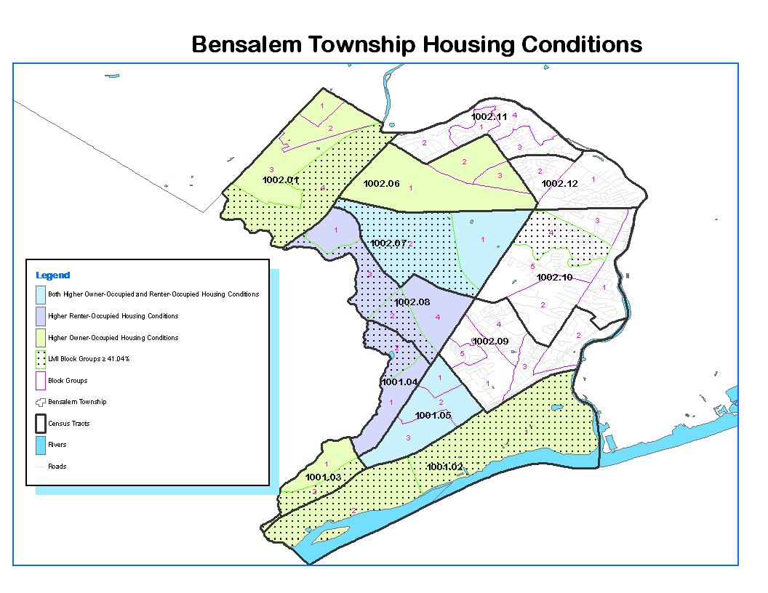

**Are there any areas in the jurisdiction where racial or ethnic minorities or low-income families are concentrated? (include a definition of "concentration")**

HUD defines areas of racial (minority) or ethnic concentration as geographical areas where the percentage of minorities or ethnic persons is 10 percentage points higher than the Township overall.

In Bensalem Township, minorities comprised 21.5% of the population. Therefore, an area of minority concentration includes census tracts where the percentage of minority persons is 31.5% or higher. There were two census tracts where the 31.5 % threshold was met.

* Census Tract 1001.04: 32%
* Census Tract 1002.09: 39.7%.

In Bensalem Township, persons of Hispanic origin comprised 5% of the population, a decline from 6.7% in 2009. Therefore, an area of ethnic concentration includes census tracts where the percentage of Hispanics is 15% or higher. No census tracts met this threshold.

The following table presents the Bensalem Township population by race and Hispanic origin by census tract for areas of minority and ethnic concentration. Areas of concentration are highlighted below:



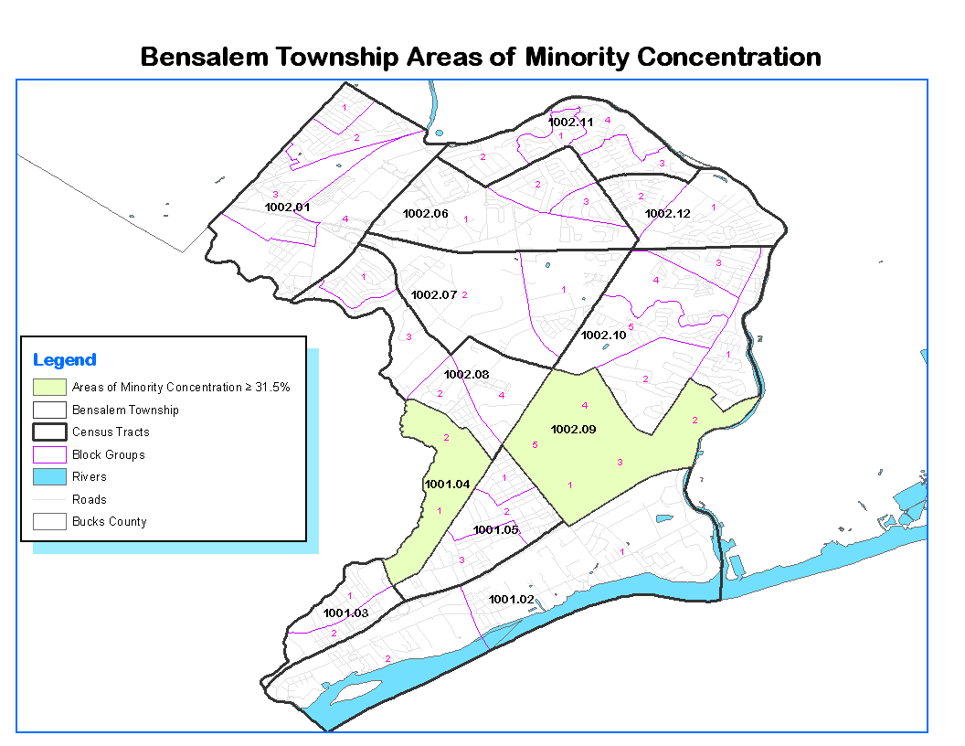

Within Bensalem Township, there are nine census block groups which contain a majority of low- and moderate-income (LMI) persons. These nine census block group areas are so designated because the percentage of LMI persons within each block group is greater than 51.0%. These are highlighted in the table below.



The following map highlights the low- and moderate- income (LMI) areas in Bensalem Township:

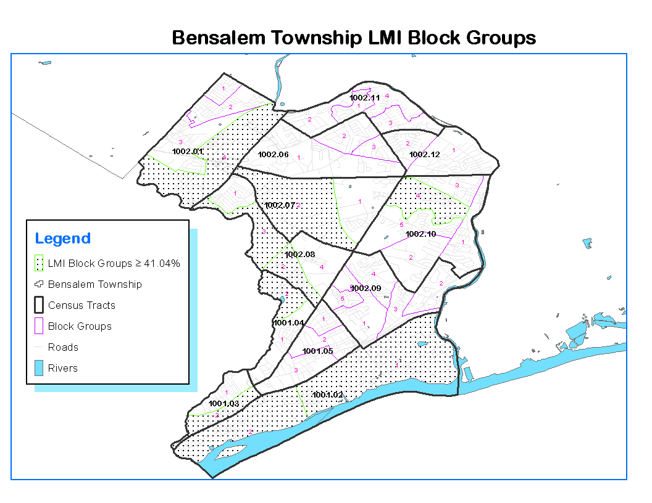

The following map highlights the areas of the Township that are both LMI and contain areas of minority and/or ethnic concentration. There is only one block group in Bensalem Township where the two factors overlap: Census Tract 1001.04, Block Group 2.

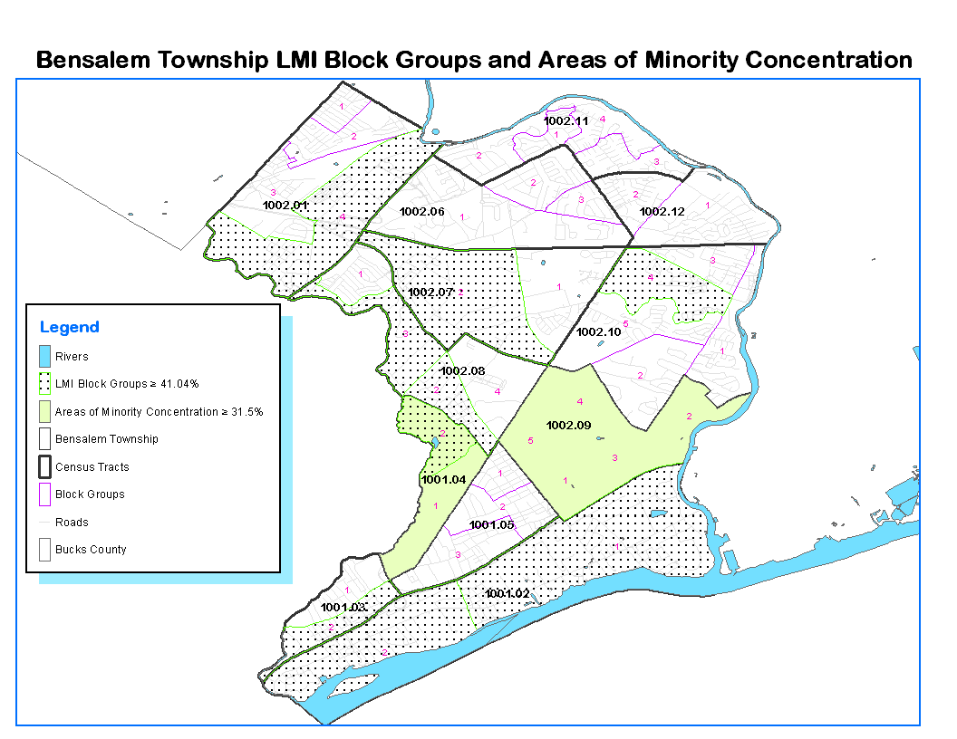

**What are the characteristics of the market in these areas/neighborhoods?**

Many of the LMI areas tend to be located in areas of the Township that contain more rental units, with an older housing stock. The housing market appreciation in these areas also tends to be slower than the Township as a whole.

**Are there any community assets in these areas/neighborhoods?**

There are numerous assets in these areas, including employment centers, close proximity to transportation centers, including the SEPTA line to Philadelphia and New Jersey, access to I-95, shopping centers, churches and schools, and industrial companies. It is a diverse area.

**Are there other strategic opportunities in any of these areas?**

There are opportunities for greater housing and business development to leverage the strengths of the current economy. In addition, the proposed Waterfront development will create more employment opportunities for area residents, in addition to housing units and shopping options.

# Strategic Plan

## SP-05 Overview

**Strategic Plan Overview**

***Geographic Priorities***

The Township will focus the majority of funds in defined low/moderate-income (LMI) areas.

***Priority Needs***

The Township has identified improving the existing housing stock, ADA curb improvements, and clearance and demolition as priority needs for the next five years.

***Influence of Market Conditions***

An inadequate supply of affordable housing, especially for extremely low- and low-income persons, is the major housing problem in the area.

***Anticipated Resources***

The Township anticipates receiving approximately $1,265,000 in CDBG funding over the next five years.

***Institutional Delivery Structure***

The Township relies on a network of public sector, private sector, and non-profit organizations to implement the Strategic Plan, particularly to address homelessness and special needs.

***Goals***

*See SP-45: Goals Summary*

***Public Housing***

The Township will continue to support the efforts of the Bucks County Housing Authority (BCHA) to supply affordable housing to area residents.

***Barriers to Affordable Housing***

An Analysis of Impediments to Fair Housing Choice (AI) was recently completed (March 2014) for the Urban County of Bucks County and Bensalem Township that evaluated current public and private sector policies and provided recommendations for action steps to promote fair housing choice.

***Homelessness Strategy***

The Township works with the Housing Continuum of Care-Bucks County (HCoC-BC) to provide homeless services and emergency, transitional, and permanent housing for homeless individuals and families, including veterans, those with special needs, the disabled, HIV/AIDS, and victims of domestic violence.

***Anti-Poverty Strategy***

The Township’s efforts to address poverty are based on partnerships with other organizations that work to address the underlying causes of poverty. The Township will continue to leverage its existing CDBG allocations with other public and private resources to address the issue of poverty.

## SP-10 Geographic Priorities - 91.415, 91.215(a)(1)

**Geographic Area**

CDBG funds are intended to provide low and moderate-income households with viable communities, including decent housing, a suitable living environment, and expanded economic opportunities. Eligible activities to be funded with CDBG funds include public improvements, housing rehabilitation and preservation, affordable housing development activities, public services, economic development, planning, and administration.

The system for establishing the priority for the selection of these projects is predicated upon the following criteria:

* Meeting the statutory requirements of the CDBG and HOME programs;
* Meeting the needs of very-low, low-, and moderate-income residents;
* Focusing on low- and moderate-income persons, areas, or neighborhoods;
* Coordinating and leveraging resources;
* Responding to expressed needs;
* Achieving sustainability and/or long-term impact;
* Having the ability to measure or demonstrate progress and success.

Bensalem Township is a special exception community under HUD regulations and the minimum threshold for CDBG eligibility for the Township is 41.04%. Of the three non-administrative CDBG activities planned for FY 2015, one, the curb cut program, has a citywide benefit. The second program, housing rehabilitation, is for low- and moderate-income households who must meet income-eligibility limits, and the third program is for operational support of a homeless shelter, Family Services of Bucks County.

## SP-25 Priority Needs - 91.415, 91.215(a)(2)

**Priority Needs**

The IDIS-generated table below shows priority needs for Bensalem Township. Priority needs were included based on the results of public input, especially the community needs assessment survey results. Additional needs were identified through stakeholder interviews and consultation with service agencies.

Needs were given a priority level of high or low based on whether the need could be addressed with CDBG funding and the degree to which other resources might be available to address the need. Bensalem Township intends to use CDBG resources to address high priorities, and expects other funding sources or community stakeholders to address other community needs.

Table 13 – Priority Needs Summary

|  |  |  |
| --- | --- | --- |
| **1** | **Priority Need Name** | Improve the Housing Stock |
| **Priority Level** | High |
| **Population** | Extremely Low Low Moderate Large Families Families with Children Elderly |
| **Geographic Areas Affected** | Township-wide for qualified low- and moderate-income households. |
| **Associated Goals** | Housing Rehabilitation Program |
| **Description** | Protection of the housing stock through rehabilitation helps to stabilize neighborhoods, eliminate blighting influences and preserve the local tax base.  With a significant portion of the Township’s housing stock constructed prior to 1950, there is a considerable need for housing rehabilitation.  In addition to the age of housing, the potential for lead-based paint hazards threatens over half of all housing units affordable to persons at 80% or less of MFI. |
| **Basis for Relative Priority** | Preserving and improving the existing housing stock continues to be a high-priority for the Township. |
| **2** | **Priority Need Name** | Public Infrastructure Improvements |
| **Priority Level** | High |
| **Population** | Persons with Physical Disabilities Non-housing Community Development |
| **Geographic Areas Affected** | Township-wide |
| **Associated Goals** | Curb Cut Program |
| **Description** | Public infrastructure in many CDBG-eligible areas of Bensalem is inadequate for current demands.  Priority projects in the infrastructure category include curb cut improvements to remove architectural barriers for the disabled. |
| **Basis for Relative Priority** | Bensalem Township will continue to support public infrastructure projects, including curb cut improvements. |
| **3** | **Priority Need Name** | Address Homelessness |
| **Priority Level** | High |
| **Population** | Chronic Homelessness Individuals Families with Children Mentally Ill Persons with HIV/AIDS Victims of Domestic Violence |
| **Geographic Areas Affected** | County-wide (facility is located in the Levittown section of Bucks County). |
| **Associated Goals** | Homeless Shelter Assistance |
| **Description** | Bensalem Township will provide CDBG funds to support the operational cost of Family Services of Bucks County. This program addresses the needs of the homeless and provides guidance and assistance in securing permanent housing for individuals and families. |
| **Basis for Relative Priority** | Providing assistance to address homelessness continues to be a high priority. |

**SP-35 Anticipated Resources - 91.420(b), 91.215(a)(4), 91.220(c)(1,2)**

**Introduction**

The following federal resources will be used to address the identified needs in Bensalem Township in FY 2015.

**Anticipated Resources**

| **Program** | **Source of Funds** | **Uses of Funds** | **Expected Amount Available Year 1** | | | | **Expected Amount Available Reminder of ConPlan**  **$** |
| --- | --- | --- | --- | --- | --- | --- | --- |
| **Annual Allocation: $** | **Program Income: $** | **Prior Year Resources: $** | **Total:**  **$** |
| CDBG | public - federal | Acquisition Admin and Planning Economic Development Housing Public Improvements Public Services | $253,042 | 0 | 0 | $253,042 | $1,012,168 |

Table 14 - Anticipated Resources

**Explain how federal funds will leverage those additional resources (private, state and local funds), including a description of how matching requirements will be satisfied**

Bensalem Township continues to leverage public and private resources where possible to expand the supply of decent, affordable housing available to the area’s lowest-income households. While the Township does not directly provide public housing units, it continues to work with landlords and other local stakeholders to ensure that well-maintained and affordable properties are available to Section 8 voucher holders. Additionally, the Township and Bucks County offer a wide spectrum of supportive services available to assist lower-income households. The Township will continue to work with county agencies, other assisted housing providers and social service agencies in efforts to coordinate programs and services.

**If appropriate, describe publically owned land or property located within the state that may be used to address the needs identified in the plan**

Not applicable.

**SP-40 Institutional Delivery Structure - 91.415, 91.215(k)**

Explain the institutional structure through which the jurisdiction will carry out its consolidated plan including private industry, non-profit organizations, and public institutions.

|  |  |  |  |
| --- | --- | --- | --- |
| **Responsible Entity** | **Responsible Entity Type** | **Role** | **Geographic Area Served** |
| Bensalem Township Department of Planning | Government Agency | Coordinator | Township |
| Housing Continuum of Care-Bucks County (HCoC-BC) | Coalition of agencies | Coordinator | County |
| Bucks County Division of Human Services | Government | Senior Services, Children and Youth, Mental Health, Homelessness | Other-County |
| Bensalem Township Planning Commission | Government | Planning | Other-Township |
| Bensalem Economic Development Corporation | Regional organization | Community development: economic development | Other-Township |

Table 15 - Institutional Delivery Structure

**Assess of Strengths and Gaps in the Institutional Delivery System**

The following table provides a description of strengths and weaknesses associated with agencies involved in the administration of the program process.

**Assessment of Institutional Structure**

|  |  |  |
| --- | --- | --- |
| **Agency** | **Strength** | **Weakness** |
| **Public** | | |
| Office of Community Development | * Coordination of programs. * Capacity to conduct varied activities. * Technical expertise. | * Limited resources. * Limited staff. |
| Bucks County Housing Authority | Housing for extremely low income including elderly and disabled. | * Limited resources. * Excessive land costs and lack of land to expand inventory. |
| County Agencies | One-stop resource for many social service, education, and employment resources. | * Limited resources. * Limited staff. |
| State Agencies (PHFA, DCED) | Varied programs to address varied housing and community development needs. | Extremely competitive process for limited resources. |
| **Non-profit** | | |
| Non-profit Organizations | Support services | * Long-term financial stability. * Technical expertise. |
| **Private** | | |
| Lenders | Underwriting, funding, servicing | * Adverse to risk. * Timeliness * Rate variation. |

Efforts to Enhance Coordination between Various Housing and Service Providers

As part of the Bucks County Consortium, the Township cooperates with the County’s Office of Community Development and its Continuum of Care plan to assist local homeless populations. The Township cooperates with the County in providing support on a local level for those programs, which provides emergency and transitional housing and support for new low-cost permanent housing. Additionally, the Township works with the Bucks County Redevelopment Authority on various housing initiatives, including compliance with lead-based paint hazard regulations.

**Availability of services targeted to homeless persons and persons with HIV and mainstream services**

| **Homelessness Prevention Services** | **Available in the Community** | **Targeted to Homeless** | **Targeted to People with HIV** |
| --- | --- | --- | --- |
| **Homelessness Prevention Services** | | | |
|  |  |  |  |
| Counseling/Advocacy |  |  |  |
| Legal Assistance |  |  |  |
| Mortgage Assistance |  |  |  |
| Rental Assistance |  |  |  |
| Utilities Assistance |  |  |  |

| **Street Outreach Services** | | | |
| --- | --- | --- | --- |
|  |  |  |  |
| Law Enforcement | **X** |  |  |
| Mobile Clinics |  |  |  |
| Other Street Outreach Services |  |  |  |

| **Supportive Services** | | | |
| --- | --- | --- | --- |
|  |  |  |  |
| Alcohol & Drug Abuse |  |  |  |
| Child Care |  |  |  |
| Education | **X** |  |  |
| Employment and Employment Training | **X** |  |  |
| Healthcare |  |  |  |
| HIV/AIDS |  |  |  |
| Life Skills |  |  |  |
| Mental Health Counseling |  |  |  |
| Transportation | **X** |  |  |

| **Other** | | | |
| --- | --- | --- | --- |
|  |  |  |  |
| Other |  |  |  |

Table 16 - Homeless Prevention Services Summary

**Describe how the service delivery system including, but not limited to, the services listed above meet the needs of homeless persons (particularly chronically homeless individuals and families, families with children, veterans and their families, and unaccompanied youth)**

As stated earlier, the Township cooperates with the Bucks County Consortium County’s Office of Community Development and its Continuum of Care to assist local homeless populations. The County has established goals to increase the number of persons who are discharged to permanent housing destinations and has implemented new projects to accomplish this goal. A new program targets transition-age youth and provides rental assistance and intensive case management and employment counseling. Rapid re-housing provides participants with assistance to rent their own permanent housing unit and continues to be a funding priority for the County, as evidenced by recent grants awarded to projects that target low-income families and chronically homeless, mentally ill and/ or substance addicted persons for rental assistance and wraparound services.

According to the CoC Program Application and Plan, the County has not established numerical goals for reducing recidivism among formerly homeless persons. However, it has targeted this issue as a major task of the CoC. The CoC is developing performance measurements and reporting requirements for this indicator via HMIS.

**Describe the strengths and gaps of the service delivery system for special needs population and persons experiencing homelessness, including, but not limited to, the services listed above**

The County is working with multiple systems to reduce the number of residents that experience homelessness at all. To strengthen the system, the CoC has initiated a Centralized Intake/ Coordinated Assessment planning process that include a heavy marketing and outreach campaign to landlords, district judges, other institutions, and renters so that residents can take advantage of diversion and prevention options before becoming homeless.

Secondly, HAP funding from PA DPW continues to be targeted towards preventing evictions and helping homeless persons move into permanent housing. HAP program parameters have been modified in order to provide assistance to more residents as the demand increases.

Third, discharge planning from institutions is a cross-systems issue that is being explored through new housing projects and collaboration on service- based training. For example, Corrections is increasing collaboration with the CoC in order to provide more housing opportunities for persons who would be homeless upon discharge and has taken advantage of CoC-wide SOAR training for disabled inmates who would be homeless upon discharge. Local hospitals have a history of collaborating with non-profit housing providers in order to offer long-term permanent housing for residents with disabilities. The Department of Children and Youth Social Services is engaged in providing housing opportunities for at-risk families with children as a diversion from foster care as well. Lastly, the CoC will be planning specific strategies and targets for discharge planning during the strategic planning process it is undertaking in 2014.

**Provide a summary of the strategy for overcoming gaps in the institutional structure and service delivery system for carrying out a strategy to address priority needs**

Bensalem Township does not receive ESG funds, but works closely with the County and the CoC to plan the use and distribution of ESG funds, as well as to develop performance measurements and outcomes for funded projects. The County also leverages the direct allocation of federal ESG funding with ESG funding available through the State at DCED.

**SP-45 Goals - 91.415, 91.215(a)(4)**

**Goals Summary Information**

| **Sort Order** | **Goal Name** | **Start Year** | **End Year** | **Category** | **Needs Addressed** | **Funding** | **Goal Outcome Indicator** |
| --- | --- | --- | --- | --- | --- | --- | --- |
| **1** | Housing Rehabilitation Program | 2015 | 2019 | Affordable Housing | Improve the Housing Stock | CDBG: $290,000 | Homeowner Housing Rehabilitated: 20 Household Housing Unit |
| **2** | Curb Cut Program | 2015 | 2019 | Non-Housing Community Development | Public Infrastructure Improvements | CDBG: $600,210 | Public Facility or Infrastructure Activities other than Low/Moderate Income Housing Benefit: 1000 Persons Assisted |
| **3** | Homeless Shelter Assistance | 2015 | 2019 | Homeless | Address Homelessness | CDBG: $137,500 | Homeless Person Overnight Shelter: 1000 Persons Assisted |

Table 17 – Goals Summary

**Goal Descriptions**

|  |  |  |
| --- | --- | --- |
| **1** | **Goal Name** | Housing Rehabilitation Program |
| **Goal Description** | The housing rehabilitation program provides up to $15,000 in deferred loans for low- and moderate-income residents.  The program is run with the assistance of the Bucks County Redevelopment Authority. |
| **2** | **Goal Name** | Curb Cut Program |
| **Goal Description** | The Township will support curb cut improvements to remove architectural barriers for disabled persons. |
| **3** | **Goal Name** | Homeless Shelter Assistance |
| **Goal Description** | The Township will continue to fund the homeless shelter now operated by Family Services of Bucks County. |

**Estimate the number of extremely low-income, low-income, and moderate-income families to whom the jurisdiction will provide affordable housing as defined by HOME 91.315(b)(2)**

Bensalem Township is part of the Bucks County HOME. The Bucks County Consolidated Plan contains the estimates for the number of affordable housing units.

## SP-65 Lead-based Paint Hazards - 91.415, 91.215(i)

**Actions to address LBP hazards and increase access to housing without LBP hazards**

The guidelines for the Township’s Housing Rehabilitation Program comply with the lead based paint hazards at 24 CFR Part 35. It is the Township’s policy to notify affected homeowners if lead based paint hazards exist in their homes. The Township often discovers these hazards while conducting rehabilitation of owner-occupied housing. The Bucks County Health Department responds to persons who have concerns about lead based paint, provides counsel to individuals on the medical problems associated with elevated lead levels in the blood, and dispenses information on trained and approved contractors and testing laboratories. The Health Department has implemented a program to screen young children for elevated levels of lead in the blood within their Well Child program and WIC clinic program and does in-home screening in targeted neighborhoods.

**How are the actions listed above integrated into housing policies and procedures?**

See above. The Township’s Single-Family Owner-Occupied Rehabilitation Program is run with the assistance of the Bucks County Redevelopment Authority, and therefore works closely with the Bucks County Health Department to address potential lead-based paint hazards.

## SP-70 Anti-Poverty Strategy - 91.415, 91.215(j)

**Jurisdiction Goals, Programs and Policies for reducing the number of Poverty-Level Families**

Poverty is a function of income, which is related to education, job training and employment. Annually Bensalem Township provides limited CDBG funds to support housing rehabilitation, curb cut improvements, and homeless assistance. The Township supports economic development efforts through its general tax revenue for the Bucks County Redevelopment Authority and the Bensalem Economic Development Corporation with the development and operation of a state Enterprise Zone program, in partnership with other municipalities. In addition, major economic development efforts in support of business development and job creation are being undertaken by Bensalem Township. This includes the proposed long-term Waterfront development discussed in MA-45, Non-Housing Community Development Assets.

**How are the Jurisdiction poverty reducing goals, programs, and policies coordinated with this affordable housing plan**

Bensalem Township’s economic development goals, programs and policies will increase the incomes of Township residents and reduce the number of people who are living in poverty. Increased income makes housing more affordable by reducing housing cost burden and by increasing the number of people who can improve their homes through the housing rehabilitation program.

## SP-80 Monitoring - 91.230

**Describe the standards and procedures that the jurisdiction will use to monitor activities carried out in furtherance of the plan and will use to ensure long-term compliance with requirements of the programs involved, including minority business outreach and the comprehensive planning requirements**

This section describes the monitoring standards and procedures that the Bensalem Township Office of Community Development (OCD) will follow during the implementation of the FY 2010-2014 Consolidated Plan. Performance monitoring is an important component in the long-term success of the Township’s CDBG Program. The OCD is responsible for ensuring that the recipients of federal funds meet the purposes of the appropriate legislation and regulations, and that funds are disbursed in a timely manner.

OCD will monitor activities carried out to further the 5-year Consolidated Plan and to ensure long-term compliance with program requirements. The objectives of this monitoring are to make sure that activities 1) comply with all regulations governing their administrative, financial, and programmatic operations; 2) achieve their performance objectives within schedule and budget; and 3) comply with the Consolidated Plan.

Internal controls have been designed to ensure adequate segregation of duties. OCD prepares agreements for housing and non-housing activities supported by CDBG funds. Invoices are monitored for compliance with the approved spending plan and federal regulations. The OCD administers the Integrated Disbursement and Information System (IDIS). OCD is also primarily responsible for setting up and administering activities. The Township’s monitoring standards and procedures ensure that statutory and regulatory requirements are being met and the information submitted to HUD is correct and complete.

The monitoring procedures and requirements of the CP will be an extension of the OCD’s existing monitoring system and experience in administering State and federal programs. The standards and procedures established by the OCD for monitoring the implementation of the CP ensure that:

* The objectives of the National Affordable Housing Act are met;
* Program activities are progressing in compliance with timely parameters;
* The use of all funds is consistent with HUD guidelines; and,
* All participating agencies are in compliance with applicable laws implementing regulations, and in particular, with requirements to affirmatively further fair housing and minimize displacement of LMI persons.

OCD monitors the various programs and activities that are funded with CDBG dollars. A subrecipient monitoring plan has been put in place to ensure compliance by agencies funded with the CDBG public service and public facilities funding. The following key components of the monitoring process ensure that the Township’s CP goals are being met in a timely and efficient manner:

* Record-keeping Systems – Record-keeping requirements outline in 24 CFR Part 570.506 are adhered to. Each project file is documented as to eligibility and national objective, the beneficiaries of the activity, procurements, agreements and related compliance issues.
* Financial Management – All financial transactions are carefully recorded and reconciled between the in-house system and IDIS.
* Audit Management – All audits are conducted in accordance with federal and State regulations, specifically federal OMB circulars A-128 and A-133.

# Expected Resources

## AP-15 Expected Resources - 91.420(b), 91.220(c)(1,2)

**Introduction**

The following federal resources will be used to address the identified needs in Bensalem Township in FY 2015.

**Anticipated Resources**

| **Program** | **Source of Funds** | **Uses of Funds** | **Expected Amount Available Year 1** | | | | **Expected Amount Available Reminder of ConPlan**  **$** |
| --- | --- | --- | --- | --- | --- | --- | --- |
| **Annual Allocation: $** | **Program Income: $** | **Prior Year Resources: $** | **Total:**  **$** |
| CDBG | public - federal | Acquisition Admin and Planning Economic Development Housing Public Improvements Public Services | $253,042 | 0 | 0 | $253,042 | $1,012,168 |

Table 18 - Expected Resources – Priority Table

**Explain how federal funds will leverage those additional resources (private, state and local funds), including a description of how matching requirements will be satisfied**

Bensalem Township continues to leverage public and private resources where possible to expand the supply of decent, affordable housing available to the area’s lowest-income households. While the Township does not directly provide public housing units, it continues to work with landlords and other local stakeholders to ensure that well-maintained and affordable properties are available to Section 8 voucher holders. Additionally, the Township and Bucks County offer a wide spectrum of supportive services available to assist lower-income households. The Township will continue to work with county agencies, other assisted housing providers and social service agencies in efforts to coordinate programs and services.

**If appropriate, describe publically owned land or property located within the jurisdiction that may be used to address the needs identified in the plan**

N/A

# Annual Goals and Objectives

**AP-20 Annual Goals and Objectives - 91.420, 91.220(c)(3)&(e)**

**Goals Summary Information**

| **Sort Order** | **Goal Name** | **Start Year** | **End Year** | **Category** | **Needs Addressed** | **Funding** | **Goal Outcome Indicator** |
| --- | --- | --- | --- | --- | --- | --- | --- |
| **1** | Housing Rehabilitation Program | 2015 | 2016 | Affordable Housing | Improve the Housing Stock | CDBG: $58,000 | Homeowner Housing Rehabilitated: 4 Household Housing Unit |
| **2** | Curb Cut Program | 2015 | 2016 | Non-Housing Community Development | Public Infrastructure Improvements | CDBG: $120,042 | Public Facility or Infrastructure Activities for Low/Moderate Income Housing Benefit: 200 Households Assisted |
| **3** | Homeless Shelter Assistance | 2015 | 2016 | Homeless |  | CDBG: $27,500 | Homeless Person Overnight Shelter: 200 Persons Assisted |

Table 19 – Goals Summary

Note that the estimated program funding amounts above are estimates and may be changed once the final funding allocations are provided by HUD. Any difference in final HUD funding allocations will be cut (or added) from the curb cut program.

**Goal Descriptions**

|  |  |  |
| --- | --- | --- |
| **1** | **Goal Name** | Housing Rehabilitation Program |
| **Goal Description** | The housing rehabilitation program provides up to $15,000 in deferred loans for low- and moderate-income residents.  The program is run with the assistance of the Bucks County Redevelopment Authority. |
| **2** | **Goal Name** | Curb Cut Program |
| **Goal Description** | The Township will support curb cut improvements to remove architectural barriers for disabled persons. |
| **3** | **Goal Name** | Homeless Shelter Assistance |
| **Goal Description** | The Township will continue to fund the homeless shelter now operated by Family Services of Bucks County. |

**AP-35 Projects - 91.420, 91.220(d)**

**Introduction**

The following projects in FY 2015 are expected to address the primary community development and housing issues that can be addressed with limited CDBG funding.

| **#** | **Project Name** |
| --- | --- |
| 1 | Homeless Shelter |
| 2 | Housing Rehab |
| 3 | Curb Cut Program |
| 4 | Program Administration |

Table 20 – Project Information

**Describe the reasons for allocation priorities and any obstacles to addressing underserved needs**

Priorities for community development were established from citizen input and a variety of consultations and meetings.

The primary obstacle to meeting underserved needs is a lack of adequate funding.  The allocation of federal CDBG funds is well below levels required to meet the needs of the Township’s LMI households and neighborhoods. In addition, funds have declined over the last five years. The two most outstanding needs in Bensalem Township continue to be safe, decent, affordable housing and jobs that pay living wages for a family to live in the community. Bensalem Township continues to focus on improving housing and expanding economic opportunities in the Township. In addition, the Township also continues to seek additional funding to leverage its CDBG funds.

Other obstacles that are evident in Bensalem Township, particularly related to housing and economic development, include the limited amount of vacant developable sites, cost-prohibitive cleanup expenses associated with abandoned buildings and former industrial sites, and a dated infrastructure that needs to be upgraded.

## AP-38 Project Summary

**Project Summary Information**

|  |  |  |
| --- | --- | --- |
| **1** | **Project Name** | Homeless Shelter |
| **Goals Supported** | Homeless Shelter Assistance |
| **Needs Addressed** | Address Homelessness |
| **Funding** | CDBG: $27,500 |
| **Description** | Operating cost for the continuation of Persons who are Homeless |
| **Target Date** | 3/31/2016 |
| **Estimate the number and type of families that will benefit from the proposed activities** | 200. |
| **Location Description** | County-wide. |
| **Planned Activities** | Operating support to Family Support Services of Bucks County to provide emergency shelter.  The facility provides emergency shelter for families and individuals; case managers assist with needed services; and the facility provides emergency shelter, food, clothing and general information referrals. The shelter can house up to 85 men, women and children.    Matrix Code: 03T |
| **2** | **Project Name** | Housing Rehab |
| **Goals Supported** | Housing Rehabilitation Program |
| **Needs Addressed** | Improve the Housing Stock |
| **Funding** | CDBG: $58,000 |
| **Description** | rehab of single family owner occupied unit |
| **Target Date** | 3/31/2016 |
| **Estimate the number and type of families that will benefit from the proposed activities** | 20. |
| **Location Description** | Township wide. |
| **Planned Activities** | Housing rehabilitation assistance in conjunction with the assistance of the county redevelopment authority for up to 4 households annually.    Matrix Code: 14A |
| **3** | **Project Name** | Curb Cut Program |
| **Target Area** | To be determined. |
| **Goals Supported** | Curb Cut Program |
| **Needs Addressed** | Public Infrastructure Improvements |
| **Funding** | CDBG: $120,042 |
| **Description** | removal of architectural barriers for the disabled |
| **Target Date** | 3/31/2016 |
| **Estimate the number and type of families that will benefit from the proposed activities** | 200. |
| **Location Description** | TBD. |
| **Planned Activities** | Curb cut improvements to enhance ADA accessibility.  Matrix Code:  03K |
| **4** | **Project Name** | Program Administration |
| **Funding** | CDBG: $47,500 |
| **Description** | Administration of the Township CDBG Program |
| **Target Date** | 3/31/2016 |
| **Estimate the number and type of families that will benefit from the proposed activities** | N/A |
| **Location Description** | Bensalem Township offices: 2400 Byberry Road. |
| **Planned Activities** | CDBG administration.  Matrix Code: 21A |

## AP-50 Geographic Distribution - 91.420, 91.220(f)

**Description of the geographic areas of the entitlement (including areas of low-income and minority concentration) where assistance will be directed**

Within Bensalem Township, there are nine census block groups which contain a majority of low- and moderate-income (LMI) persons. These nine census block group areas are so designated because the percentage of LMI persons within each block group is greater than 51.0%. These are highlighted in the table below.



In Bensalem Township, minorities comprised 21.5% of the population. Therefore, an area of minority concentration includes census tracts where the percentage of minority persons is 31.5% or higher. There were two census tracts where the 31.5 % threshold was met.

* Census Tract 1001.04: 32%
* Census Tract 1002.09: 39.7%.

In Bensalem Township, persons of Hispanic origin comprised 5% of the population, a decline from 6.7% in 2009. Therefore, an area of ethnic concentration includes census tracts where the percentage of Hispanics is 15% or higher. No census tracts met this threshold.

**Rationale for the priorities for allocating investments geographically**

Eligible activities to be funded with CDBG funds include public improvements, housing rehabilitation and preservation, affordable housing development activities, public services, economic development, planning, and administration.

The priorities presented were developed by:

* Weighing the severity of the need among all groups and sub-groups;
* Analyzing current social, housing and economic conditions;
* Analyzing the relative needs of low and moderate income families;
* Assessing the resources likely to be available over the next five years; and
* Evaluating input from focus group sessions, interviews, service provider surveys, Township department staff and public hearings.

## AP-85 Other Actions - 91.420, 91.220(k)

**Introduction**

In FY 2015, Bensalem Township plans the following actions to help address the housing and community development needs of Township residents, especially low- and moderate-income residents.

**Actions planned to address obstacles to meeting underserved needs**

The chief obstacle to meeting underserved needs is a lack of, or inadequate, resources---both financial and human (staffing). Bensalem Township will continue to collaborate with human and social service agencies and the Continuum of Care to identify potential resources for meeting the service needs of Township residents.

**Actions planned to foster and maintain affordable housing**

Bensalem Township will allocate a total of $253,042 of FY 2015 CDBG funds for community development and housing, including $58,000 for the Township’s Single Family Owner-Occupied Rehabilitation program.

**Actions planned to reduce lead-based paint hazards**

The Township’s Single-Family Owner-Occupied Rehabilitation Program is run with the assistance of the Bucks County Redevelopment Authority, and therefore works closely with the Bucks County Health Department to address potential lead-based paint hazards.

**Actions planned to reduce the number of poverty-level families**

Bensalem Township’s economic development goals, programs and policies will increase the incomes of Township residents and reduce the number of people who are living in poverty. Increased income makes housing more affordable by reducing housing cost burden and by increasing the number of people who can improve their homes through the housing rehabilitation program.

**Actions planned to develop institutional structure**

Bensalem Township relies on a network of public sector, private sector, and non-profit organizations to deliver needed housing and community development services to Township residents, particularly the homeless and special needs populations.

As an example of enhanced cooperation, the Township has served as a grantee for state grant funds for both Libertae Halfway House and Livengrin, a substance abuse facility in Bensalem. The two organizations served as sub-grantees. The Township anticipates continuing the role as a facilitator to develop institutional structure and expand the resource base to address Township issues.

**Actions planned to enhance coordination between public and private housing and social service agencies**

See previous responses.

# Program Specific Requirements

**AP-90 Program Specific Requirements - 91.420, 91.220(l)(1,2,4)**

**Introduction**

**Community Development Block Grant Program (CDBG)**

**Reference 24 CFR 91.220(l)(1)**

Projects planned with all CDBG funds expected to be available during the year are identified in the Projects Table. The following identifies program income that is available for use that is included in projects to be carried out.

|  |  |
| --- | --- |
|  | |
| 1. The total amount of program income that will have been received before  the start of the next program year and that has not yet been reprogrammed |  |
| 2. The amount of proceeds from section 108 loan guarantees that will be  used during the year to address the priority needs and specific objectives  identified in the grantee's strategic plan |  |
| 3. The amount of surplus funds from urban renewal settlements |  |
| 4. The amount of any grant funds returned to the line of credit for which the  planned use has not been included in a prior statement or plan. |  |
| 5. The amount of income from float-funded activities |  |
| Total Program Income |  |

**Other CDBG Requirements**

|  |  |
| --- | --- |
|  | |
| 1. The amount of urgent need activities |  |